Software Requirements Specification
HEALTH AI Co-Creation & Innovation Platform
Version 1.1 — Revised Edition
Field | Details
Project Name | HEALTH AI Co-Creation & Innovation Platform
Course | Software Project IV (SENG384)
Group No / Name | Co-Nova EG
Group Members | Ecem Tüysüz — 202228050 Gizem Fatma Kılıç — 202228028
Submission Date | 22/03/2026
Version | 1.2 (Revised)

Revision History
Date | Version | Change Description | Author
02/03/2026 | 1.0 | Initial SRS version | Ecem Tüysüz, Gizem Fatma Kılıç
14/03/2026 | 1.1 | Corrections: missing use cases added (UC-07–UC-12), role-specific post fields, meeting negotiation flow, data model fixes, RTM completed, NFRs added to RTM, Admin self-registration restricted | Ecem Tüysüz, Gizem Fatma Kılıç
05/05/2026 | 1.2 | Add admin dashboard information | Ecem Tüysüz,Gizem Fatma Kılıç

Table of Contents
Revision History 1
1. Introduction 4
1.1 Purpose 4
1.2 Scope 4
1.3 Definitions and Abbreviations 4
1.4 Intended Audience 5
2. Overall Description 5
2.1 Product Perspective 5
2.2 User Roles 5
2.3 Assumptions and Dependencies 6
2.4 Constraints 6
3. Functional Requirements 6
3.1 User Registration & Access Control 6
3.2 Post Management 7
3.2.1 Common Post Fields (Both Roles) 7
3.2.2 Engineer-Specific Post Fields 7
3.2.3 Healthcare Professional-Specific Post Fields 8
3.2.4 Post Management Requirements 8
3.3 Search & Matching 9
3.4 Meeting Request Workflow 9
3.5 Administrative Dashboard 10
3.6 Activity Logging & Audit Trail 11
3.7 Global Theme Management 11
4. Non-Functional Requirements 12
5. Use Cases 13
5.1 UC-01: Engineer Creates a Post 13
5.2 UC-02: Healthcare Professional Creates a Post 14
5.3 UC-03: User Sends Meeting Request 14
5.4 UC-04: Post Owner Accepts/Declines Meeting Request 14
5.5 UC-05: Admin Removes Inappropriate Post 15
5.6 UC-06: User Registration 15
5.7 UC-07: User Login 16
5.8 UC-8: Personal Data Export (GDPR Right to Portability) 16
5.9 UC-9: Post Owner Marks Partner Found 16
6. Data Model 17
7. Interface Requirements 18
7.1 User Interface (UI) 18
7.1.1 Key Screens 18
7.2 External System Interfaces 19
8. Requirements Traceability Matrix 19
9. Appendices 22
9.1 Entity Relationship Diagram 22
9.2 Use Case Diagram 23
9.3 Wireframe Screens 24

1. Introduction

1.1 Purpose
This document specifies the software requirements of the HEALTH AI Co-Creation & Innovation Platform. It defines the system's functional and non-functional requirements, user interactions, lifecycle rules, security constraints, and operational behavior.
This SRS serves as a reference for the development team and course instructor to ensure that the system implementation aligns with the project brief.

1.2 Scope
The HEALTH AI Co-Creation Platform is a secure web-based system that enables structured partner discovery between engineers and healthcare professionals through announcement-based collaboration.
The system supports user registration with institutional email addresses, structured post creation, lifecycle-controlled collaboration management, meeting request workflows, and administrative oversight.
The system does NOT provide: financial transactions, legal contract management, medical advice, patient data storage, or file-sharing functionality.

1.3 Definitions and Abbreviations
Abbreviation | Definition
SRS | Software Requirements Specification
RBAC | Role-Based Access Control
GDPR | General Data Protection Regulation
NDA | Non-Disclosure Agreement
UI | User Interface
API | Application Programming Interface
MVP | Minimum Viable Product
ER | Entity Relationship
UC | Use Case
FR | Functional Requirement
NFR | Non-Functional Requirement
RTM | Requirements Traceability Matrix

1.4 Intended Audience
This document is intended for:
- The development team implementing the system
- The course instructor evaluating the project
- System reviewers and academic evaluators
It may also serve as a reference for future system enhancements.

2. Overall Description

2.1 Product Perspective
The HEALTH AI platform addresses the lack of structured and secure interdisciplinary collaboration between engineers and healthcare professionals. Currently, partner discovery often occurs informally through personal networks, conferences, or unstructured communication channels. This creates inefficiencies, lack of transparency, and inconsistent collaboration tracking.
The platform introduces a structured announcement-based system with controlled lifecycle states and meeting workflows to ensure transparency, security, and compliance.

2.2 User Roles
Role | Description | Key Permissions
Engineer | Technical professional seeking medical collaboration. | Registration: Institutional email only  Create, edit, and close posts  Browse posts  Send / accept / reject meeting requests
Healthcare Professional | Medical domain expert seeking engineering collaboration. | Registration: Institutional email only  Create, edit, and close posts  Browse posts  Send / accept / reject meeting requests
Admin | Additionally, the Admin role shall have access to advanced system-level controls including user lifecycle management, content moderation, and audit log analysis. The Admin Dashboard shall provide a centralized interface for monitoring platform activity, enforcing compliance policies, and exporting system logs for external review. | View all users and posts  Remove inappropriate content  Suspend / deactivate accounts  Access activity logs  Monitor lifecycle transitions & statistics

2.3 Assumptions and Dependencies
- Users possess a valid institutional (.edu) email address.
- Users have internet access and modern web browsers.
- Meetings occur through external platforms (e.g., Zoom, Microsoft Teams).
- Email verification service is available for account activation.
- Database system supports relational data modeling.
- Admin accounts are created through a secure back-end provisioning process, not through the public registration form.

2.4 Constraints
- The system shall not store patient data.
- The system shall not allow file uploads.
- Meetings must occur externally; the system does not host video calls.
- Registration is restricted to institutional email addresses (.edu).
- The system must comply with GDPR principles.
- Admin role cannot be selected during self-registration.

3. Functional Requirements

3.1 User Registration & Access Control
ID | Requirement Description | Priority | Source
FR-01 | The system shall only allow registration with institutional .edu email addresses. | High | Brief 4.1
FR-02 | The system shall implement an email verification mechanism before activating an account. | High | Brief 4.1
FR-03 | The user shall be able to select a role during registration (Engineer / Healthcare Professional only). The Admin role shall NOT be available in the self-registration form. | High | Brief 4.1 / Security
FR-04 | The system shall encrypt and securely store user passwords using an industry-standard algorithm (e.g., bcrypt). | High | Brief 4.1
FR-05 | The system shall implement role-based access control (RBAC). | High | Brief 4.1
FR-06 | The system shall allow users to log in and log out securely. | High | Brief 4.1
FR-07 | The system shall allow administrators to suspend or deactivate user accounts. | Medium | Brief 4.5
FR-08 | The system shall restrict access to administrative functions to users with the Admin role only. | High | Brief 4.5
FR-09 | The system shall provide a password reset flow (“Forgot Password”) via a time-limited email link. | High | Brief 4.1 / Security

3.2 Post Management
Posts are role-specific. The required fields differ based on the author's role as described below.

3.2.1 Common Post Fields (Both Roles)
Field | Required? | Notes
Title | Yes
Collaboration type | Yes | Advisor / Co-Founder / Research Partner
Confidentiality level | Yes | Public short pitch OR "Details in meeting only"
Expiry date | Yes
Project stage | Yes | Idea / Concept Validation / Prototype / Pilot Testing / Pre-Deployment
Commitment level | Yes
Country | Yes
City | Yes
Auto-close on partner found | Optional | Boolean flag

3.2.2 Engineer-Specific Post Fields
Field | Required? | Notes
Working domain | Yes | e.g., Cardiology Imaging
Short explanation | Yes
Healthcare expertise needed | Yes | What kind of clinical expertise is sought
High-level idea | Yes | Without revealing sensitive IP details

3.2.3 Healthcare Professional-Specific Post Fields
Field | Required? | Notes
Medical field | Yes | e.g., Cardiology
Short explanation | Yes
Desired technical expertise | Yes | What engineering skill is needed

3.2.4 Post Management Requirements
ID | Requirement Description | Priority | Source
FR-10 | The system shall present role-specific post creation forms: engineers see fields defined in 3.2.2, healthcare professionals see fields defined in 3.2.3, both see common fields in 3.2.1. | High | Brief 4.2
FR-11 | The system shall support the following post lifecycle states: Draft → Active → Meeting Scheduled → Partner Found (Closed) | Expired. | High | Brief 4.2
FR-12 | The system shall allow users to edit posts only while in Draft or Active state. Posts in Meeting Scheduled, Partner Found, or Expired state are read-only. | High | Brief 4.2
FR-13 | The system shall allow post owners to manually mark a post as "Partner Found", transitioning its status to Closed. | High | Brief 4.2
FR-14 | The system shall automatically transition posts to Expired state when their expiry date is reached (scheduled background job). | Medium | Brief 4.2
FR-15 | The system shall prevent editing of posts in Partner Found or Expired state. | High | Brief 4.2
FR-16 | The system shall prohibit file uploads, patient data uploads, and document repository functionality. | High | Brief 4.2
FR-17 | The system shall support an auto-close flag on posts. When enabled, the post automatically transitions to Partner Found (Closed) once the first meeting request is accepted. | Medium | Brief 4.2
FR-18 | A post transitions from Draft to Active only when the user explicitly clicks "Publish". Saving without publishing retains Draft status. | High | Brief 4.2

3.3 Search & Matching
ID | Requirement Description | Priority | Source
FR-19 | The system shall allow users to browse Active posts. | High | Brief 4.3
FR-20 | The system shall allow filtering posts by domain, required expertise, city, country, project stage, and status. | High | Brief 4.3
FR-21 | The system shall highlight city-based matches visually. | Medium | Brief 4.3
FR-22 | The system shall display a match explanation for each result (e.g., "Shared expertise: Cardiology Imaging"). | Medium | Brief 4.3
FR-23 | The system shall prevent Draft, Expired, or Partner Found posts from appearing in search results. Meeting Scheduled posts shall remain visible but display a "Meeting in progress" badge. | High | Brief 4.3

3.4 Meeting Request Workflow
The meeting workflow supports a two-step negotiation: the requester proposes time slots, the post owner selects or counter-proposes, and both parties agree before meeting externally.
ID | Requirement Description | Priority | Source
FR-24 | The system shall allow authenticated users to send meeting requests for Active posts. | High | Brief 4.4
FR-25 | The system shall require NDA acceptance before a meeting request can be submitted. The NDA confirmation screen shall display a summary of the NDA terms and record the user's acceptance timestamp. | High | Brief 4.4
FR-26 | The system shall allow the requester to propose up to 3 time slots when sending a meeting request. | High | Brief 4.4
FR-27 | The system shall allow post owners to accept or decline a meeting request. | High | Brief 4.4
FR-28 | When a post owner accepts a meeting request, the system shall update the post status to "Meeting Scheduled" and notify both parties. | High | Brief 4.4
FR-29 | The system shall allow either party to cancel an accepted meeting request. Upon cancellation, the post status shall revert to Active. | Medium | Brief 4.4
FR-30 | The system shall prevent new meeting requests when a post is in Partner Found or Expired state. | High | Brief 4.4
FR-31 | The system shall send email notifications for: new meeting request received, meeting request accepted, meeting request declined, meeting request cancelled. | High | Brief 4.4

3.5 Administrative Dashboard
ID | Requirement Description | Priority | Source
FR-32 | The system shall provide an administrative dashboard accessible only to Admin users. | High | Brief 4.5
FR-33 | The system shall allow administrators to view all posts and filter by city, domain, and status. | High | Brief 4.5
FR-34 | The system shall allow administrators to remove inappropriate posts (soft-delete with audit record). | High | Brief 4.5
FR-35 | The system shall allow administrators to view the full lifecycle history of any post. | Medium | Brief 4.5
FR-36 | The system shall allow administrators to view all registered users, filter by role, and view profile completeness metrics. | High | Brief 4.5
FR-37 | The system shall allow administrators to view user activity metrics (last login, number of posts, meeting requests sent/received). | Medium | Brief 4.5
FR-38 | The system shall provide platform statistics including: total posts, active posts, closed posts, registered users, and total meeting requests. Statistics shall update in near-real-time (within 60 seconds). | Medium | Brief 4.5
FR-52 | The system shall allow administrators to filter users by role (Engineer / Healthcare Professional / Admin). | High | Admin Extension
FR-53 | The system shall allow administrators to suspend and reactivate user accounts. | High | Admin Extension
FR-54 | The system shall allow administrators to permanently delete posts that violate platform rules. | High | Admin Extension
FR-55 | The system shall allow administrators to view audit logs in a tabular format within the Admin Dashboard. | High | Admin Extension
FR-56 | The system shall allow administrators to filter audit logs by date and action type. | High | Admin Extension
FR-57 | The system shall allow administrators to export audit logs as a CSV file. | Medium | Admin Extension

3.6 Activity Logging & Audit Trail
ID | Requirement Description | Priority | Source
FR-39 | The system shall log login and logout events. | High | Brief 4.6
FR-40 | The system shall log failed login attempts. | High | Brief 4.6
FR-41 | The system shall log post creation, editing, status transitions, and closure events. | High | Brief 4.6
FR-42 | The system shall log all meeting request events (sent, accepted, declined, cancelled). | High | Brief 4.6
FR-43 | The system shall log all administrative actions (post removal, account suspension, etc.). | High | Brief 4.6
FR-44 | The system shall log security-related events including suspicious login attempts and access violations. | High | Brief 4.6
FR-45 | Each log record shall include: timestamp, user_id, role, action_type, target_entity, target_id, result_status, and optionally IP address (stored GDPR-compliantly). | High | Brief 4.6
FR-46 | Logs shall not contain patient data. Data minimization principles apply. | High | Brief 4.6 / GDPR
FR-47 | The system shall retain logs for 24 months and implement tamper-resistance (append-only log store or equivalent). | High | Brief 4.6
FR-48 | The system shall allow administrators to filter logs by user, date range, and action type, and export as CSV. | Medium | Brief 4.6

3.7 Global Theme Management

ID | Requirement Description | Priority | Source
FR-49 | The system shall allow users to toggle between Light Mode and Dark Mode via the user interface. | Medium | UI Enhancement
FR-50 | The system shall persist the user's theme preference using local storage. | Medium | UI Enhancement
FR-51 | The system shall automatically apply the saved theme preference upon subsequent user sessions. | Medium | UI Enhancement

4. Non-Functional Requirements
ID | Requirement | Metric / Target | Category
NFR-01 | Search results shall be returned within a specified time. | < 1.5 seconds | Performance
NFR-02 | Page load time shall be limited. | < 3 seconds | Performance
NFR-03 | The system shall support concurrent active users. | ≥ 1000 concurrent users | Performance
NFR-04 | All communications shall be secured using HTTPS. | 100% HTTPS enforced | Security
NFR-05 | User passwords shall be securely hashed. | bcrypt or equivalent (cost ≥ 12) | Security
NFR-06 | User sessions shall automatically expire after inactivity. | Session timeout ≤ 30 minutes (configurable by admin) | Security
NFR-07 | The system shall implement rate limiting to prevent brute-force attacks. | ≥ 5 failed attempts → 15-minute lock | Security
NFR-08 | The system shall implement anti-bot protection on registration and login forms. | CAPTCHA or equivalent mechanism | Security
NFR-09 | The system shall collect minimal personal data. | Only role, institutional email, full name, and basic profile info stored | GDPR / Privacy
NFR-10 | Users shall be able to delete their accounts and all associated data. | Account deletion processed within 24 hours | GDPR / Privacy
NFR-11 | Users shall be able to export all their personal data. | Downloadable JSON or CSV format | GDPR / Privacy
NFR-12 | The system shall not store patient data. | 0 patient records stored | GDPR / Privacy
NFR-13 | A clear privacy policy shall be accessible from all pages. | Link in footer; policy covers data collected, retention, rights | GDPR / Privacy
NFR-14 | Users shall understand the platform purpose quickly. | Platform purpose understandable within 20 seconds (usability test) | Usability
NFR-15 | Announcement creation shall be simple. | ≤ 3 steps required | Usability
NFR-16 | Posting an announcement shall be efficient. | ≤ 3 minutes completion time | Usability
NFR-17 | Sending a meeting request shall be quick. | ≤ 30 seconds | Usability
NFR-18 | The system shall provide clear status indicators for posts. | All lifecycle states visually distinguishable (color-coded) | Usability
NFR-19 | The system shall comply with accessibility standards. | WCAG 2.1 Level AA compliant | Accessibility
NFR-20 | The system shall be mobile responsive. | Fully functional on screens ≥ 320px width | Accessibility

5. Use Cases

5.1 UC-01: Engineer Creates a Post
Field | Details
Name | UC-01: Engineer Creates a Post
Actor(s) | Engineer
Precondition | The engineer must be logged in with a verified account.
Main Flow | 1. Engineer clicks "New Post". 2. System presents the engineer-specific post form (fields per Section 3.2.1 + 3.2.2). 3. Engineer fills in all required fields. 4. Engineer saves as Draft or clicks "Publish". 5. If Published: system sets status to Active and post becomes visible to others. 6. System logs the creation event.
Postcondition (Publish) | Post is Active and visible to other authenticated users.
Postcondition (Draft) | Post is saved in Draft state and not visible to other users.
Alternative Flow | 3a. If a required field is missing, system displays a field-level validation error and prevents submission.

5.2 UC-02: Healthcare Professional Creates a Post
Field | Details
Name | UC-02: Healthcare Professional Creates a Post
Actor(s) | Healthcare Professional
Precondition | The healthcare professional must be logged in with a verified account.
Main Flow | 1. User clicks "New Post". 2. System presents the healthcare professional-specific post form (fields per Section 3.2.1 + 3.2.3). 3. User fills in all required fields. 4. User saves as Draft or clicks "Publish". 5. If Published: system sets status to Active. 6. System logs the creation event.
Postcondition (Publish) | Post is Active and visible to authenticated users.
Postcondition (Draft) | Post saved in Draft, not visible to others.
Alternative Flow | 3a. Required field missing → field-level validation error, submission blocked.

5.3 UC-03: User Sends Meeting Request
Field | Details
Name | UC-03: User Sends Meeting Request
Actor(s) | Engineer / Healthcare Professional (requester)
Precondition | User is logged in. Target post is in Active status. User has not already sent a pending request to this post.
Main Flow | 1. User opens an Active post. 2. User clicks "Send Meeting Request". 3. System displays NDA summary and acceptance checkbox. 4. User reads and accepts the NDA (timestamp recorded). 5. User proposes up to 3 time slots for the meeting. 6. User submits the request. 7. System creates meeting request with Pending status. 8. System notifies the post owner via email.
Postcondition | Meeting request stored with Pending status; post owner notified.
Alternative Flow | 4a. User declines NDA → system blocks submission and displays message. 5a. No time slot provided → validation error.

5.4 UC-04: Post Owner Accepts/Declines Meeting Request
Field | Details
Name | UC-04: Post Owner Accepts or Declines Meeting Request
Actor(s) | Engineer / Healthcare Professional (post owner)
Precondition | Post owner is logged in. At least one meeting request exists with Pending status for their post.
Main Flow (Accept) | 1. Post owner navigates to incoming meeting requests. 2. Owner selects a Pending request. 3. Owner clicks "Accept". 4. System updates meeting request status to Accepted. 5. System updates post status to Meeting Scheduled. 6. System notifies requester via email. 7. System logs the action.
Main Flow (Decline) | 3a. Owner clicks "Decline". 4a. System updates request status to Rejected. 5a. Post remains Active. 6a. System notifies requester. 7a. System logs the action.
Postcondition (Accept) | Meeting request is Accepted; post is Meeting Scheduled.
Postcondition (Decline) | Meeting request is Rejected; post remains Active.

5.5 UC-05: Admin Removes Inappropriate Post
Field | Details
Name | UC-06: Admin Removes Inappropriate Post
Actor(s) | Admin
Precondition | Admin is logged in.
Main Flow | 1. Admin opens the Admin Dashboard. 2. Admin searches or filters posts. 3. Admin selects a post. 4. Admin clicks "Remove" and enters a removal reason. 5. System soft-deletes the post (hidden from users; audit record retained). 6. System logs the admin action with reason.
Postcondition | Post is no longer visible to non-admin users; audit record preserved.
Alternative Flow | 4a. Admin cancels → no changes made.

5.6 UC-06: User Registration
Field | Details
Name | UC-07: User Registration
Actor(s) | Engineer / Healthcare Professional
Precondition | User does not have an existing account. User has a valid .edu email address.
Main Flow | 1. User navigates to Registration page. 2. User enters: full name, institutional (.edu) email, password, role (Engineer or Healthcare Professional). 3. System validates email domain is institutional. 4. System sends verification email. 5. User clicks verification link. 6. System activates account.
Postcondition | Verified user account created and stored.
Alternative Flow | 2a. Email is non-institutional → system rejects registration with error message. 3a. Email already registered → system displays error. 5a. Verification link expires (24h) → user can request new link.

5.7 UC-07: User Login
Field | Details
Name | UC-08: User Login
Actor(s) | Engineer / Healthcare Professional / Admin
Precondition | User has a verified account.
Main Flow | 1. User navigates to Login page. 2. User enters email and password. 3. System validates credentials. 4. System creates a secure session. 5. User is redirected to their dashboard.
Postcondition | User is authenticated and logged into the system.
Alternative Flow | 2a. Invalid credentials → error message displayed; failed attempt logged. 2b. ≥ 5 failed attempts → account temporarily locked for 15 minutes.

5.8 UC-8: Personal Data Export (GDPR Right to Portability)
Field | Details
Name | UC-11: Personal Data Export
Actor(s) | Engineer / Healthcare Professional
Precondition | User is logged in.
Main Flow | 1. User navigates to Account Settings. 2. User clicks "Export My Data". 3. System compiles personal data (profile, posts, meeting requests, NDA records). 4. System generates a downloadable JSON or CSV file. 5. System sends download link to user's email within 24 hours. 6. System logs the export request.
Postcondition | User receives a download link to their personal data.

5.9 UC-9: Post Owner Marks Partner Found
Field | Details
Name | UC-12: Post Owner Marks Partner Found
Actor(s) | Engineer / Healthcare Professional (post owner)
Precondition | Post is in Active or Meeting Scheduled state.
Main Flow | 1. Post owner opens their post. 2. Owner clicks "Mark as Partner Found". 3. System updates post status to Partner Found (Closed). 4. System sends notification to any pending requesters that the post is closed. 5. System logs the closure event.
Postcondition | Post is Closed; no further meeting requests accepted; pending requesters notified.

6. Data Model
Entity | Key Fields | Relationships
User | user_id (UUID, PK) full_name (varchar) email (varchar, unique) password_hash (varchar) role (enum: Engineer, HealthcareProfessional, Admin) is_active (boolean) created_at (timestamp) updated_at (timestamp) | 1 User → N Posts 1 User → N MeetingRequests (sent) 1 User → N MeetingRequests (received) 1 User → N ActivityLog records
Post | post_id (UUID, PK) user_id (UUID, FK → User) title (varchar) domain (varchar) description (text) required_expertise (varchar) project_stage (enum) commitment_level (enum) confidentiality_level (enum) estimated_collaboration_type (enum) country (varchar) city (varchar) expiry_date (date) auto_close (boolean) status (enum: Draft, Active, MeetingScheduled, PartnerFound, Expired) created_at (timestamp) updated_at (timestamp) | 1 Post → N MeetingRequests 1 Post → N ActivityLog records N Post → 1 User
MeetingRequest | request_id (UUID, PK) post_id (UUID, FK → Post) sender_id (UUID, FK → User) receiver_id (UUID, FK → User) nda_accepted (boolean) nda_accepted_at (timestamp) status (enum: Pending, Accepted, Rejected, Cancelled) created_at (timestamp) updated_at (timestamp) | N MeetingRequests → 1 Post 1 sender (User) 1 receiver (User)
ProposedSlot | slot_id (UUID, PK) request_id (UUID, FK → MeetingRequest) proposed_time (timestamp) order_index (int) | N ProposedSlots → 1 MeetingRequest (Supports up to 3 slots per FR-26)
ActivityLog | log_id (UUID, PK) user_id (UUID, FK → User) role (enum) action_type (varchar) target_entity (varchar) target_id (UUID) timestamp (timestamp) result_status (varchar) ip_address (varchar, nullable, GDPR-compliant) | N ActivityLog records → 1 User target_id references Post or MeetingRequest

7. Interface Requirements

7.1 User Interface (UI)
The HEALTH AI platform will provide a clean, structured, and user-friendly web interface prioritizing usability, clarity, and minimal complexity per Section 4.

7.1.1 Key Screens
Screen | Description
Landing Page | Introduces the platform and provides access to Login and Registration.
Registration Page (Engineer / Healthcare Professional) | Allows users to create accounts with role-specific inputs and institutional email validation.
Login Page | Enables secure authentication and access to the system.
User Dashboard | Displays user activity summary including posts, requests, and meetings. Supports both empty and populated states.
Browse Posts Page | Allows users to explore and filter active collaboration posts and initiate requests.
Create Post Page | Provides role-specific forms for creating collaboration posts with validation.
My Posts Page | Displays user-created posts with lifecycle status and management actions.
Profile Page (Engineer / Healthcare Professional) | Shows user information including role-specific attributes such as medical specialization.
Requests Page – Pending State | Displays incoming collaboration requests awaiting user action.
Requests Page – Decision State | Allows users to accept or reject incoming requests.
Meeting Scheduling Page | Enables users to define meeting details after request acceptance.
Requests Page – Accepted State | Displays accepted requests along with meeting details.
Dashboard with Meetings | Shows upcoming scheduled meetings with direct access links.
Admin Dashboard | Provides administrative controls including user management, post moderation, and system monitoring.

7.2 External System Interfaces
System | Purpose | Notes
Email Service (SMTP / SES) | Account verification, password reset, meeting notifications | Must support transactional email delivery within 2 minutes
External Meeting Platforms | Zoom, Microsoft Teams | Platform stores only meeting time and external link; does not host calls
Web Browser | Chrome, Edge, Firefox (latest 2 versions) | No native mobile app in MVP scope

8. Requirements Traceability Matrix
Req. ID | Requirement Summary | Source (Brief) | Related Use Case
FR-01 | Restrict registration to .edu emails | Brief 4.1 | UC-07
FR-02 | Email verification mechanism | Brief 4.1 | UC-07
FR-03 | Role selection (no Admin self-register) | Brief 4.1 / Security | UC-07
FR-04 | Password hashing | Brief 4.1 | UC-07, UC-08
FR-05 | RBAC | Brief 4.1 | UC-07, UC-08
FR-06 | Secure login and logout | Brief 4.1 | UC-08
FR-07 | Admin suspends accounts | Brief 4.5 | UC-06
FR-08 | Admin-only access restriction | Brief 4.5 | UC-06
FR-09 | Password reset flow | Brief 4.1 | UC-09
FR-10 | Role-specific post forms | Brief 4.2 | UC-01, UC-02
FR-11 | Post lifecycle states | Brief 4.2 | UC-01, UC-02, UC-04, UC-05, UC-12
FR-12 | Edit Draft/Active posts only | Brief 4.2 | UC-01, UC-02
FR-13 | Mark partner found | Brief 4.2 | UC-12
FR-14 | Automatic post expiration | Brief 4.2 | — (background job)
FR-15 | Prevent editing closed posts | Brief 4.2 | UC-01, UC-02, UC-12
FR-16 | Prohibit file uploads | Brief 4.2 | UC-01, UC-02
FR-17 | Auto-close flag | Brief 4.2 | UC-04, UC-12
FR-18 | Draft → Active on publish | Brief 4.2 | UC-01, UC-02
FR-19 | Browse Active posts | Brief 4.3 | UC-03
FR-20 | Filter posts | Brief 4.3 | UC-03
FR-21 | City-based match highlight | Brief 4.3 | UC-03
FR-22 | Match explanation | Brief 4.3 | UC-03
FR-23 | Hide inactive posts from search | Brief 4.3 | UC-03
FR-24 | Send meeting request | Brief 4.4 | UC-03
FR-25 | NDA acceptance required | Brief 4.4 | UC-03
FR-26 | Propose up to 3 time slots | Brief 4.4 | UC-03
FR-27 | Accept / decline meeting request | Brief 4.4 | UC-04
FR-28 | Update post to Meeting Scheduled | Brief 4.4 | UC-04
FR-29 | Cancel meeting → revert to Active | Brief 4.4 | UC-05
FR-30 | Block new requests on closed posts | Brief 4.4 | UC-03
FR-31 | Email notifications for meeting events | Brief 4.4 | UC-03, UC-04, UC-05
FR-32 | Admin dashboard | Brief 4.5 | UC-06
FR-33 | Admin views and filters posts | Brief 4.5 | UC-06
FR-34 | Admin removes posts | Brief 4.5 | UC-06
FR-35 | Admin views post lifecycle history | Brief 4.5 | UC-06
FR-36 | Admin views all users | Brief 4.5 | UC-06
FR-37 | Admin views activity metrics | Brief 4.5 | UC-06
FR-38 | Platform statistics | Brief 4.5 | UC-06
FR-39 | Log login/logout | Brief 4.6 | UC-08
FR-40 | Log failed logins | Brief 4.6 | UC-08
FR-41 | Log post events | Brief 4.6 | UC-01, UC-02, UC-12
FR-42 | Log meeting request events | Brief 4.6 | UC-03, UC-04, UC-05
FR-43 | Log admin actions | Brief 4.6 | UC-06
FR-44 | Log security events | Brief 4.6 | UC-08
FR-45 | Log data fields | Brief 4.6 | All logged UCs
FR-46 | No patient data in logs | Brief 4.6 / GDPR | All
FR-47 | 24-month log retention | Brief 4.6 | All
FR-48 | Admin log filter & export | Brief 4.6 | UC-06
NFR-01 | Search < 1.5s | Brief 5.3 | UC-03
NFR-02 | Page load < 3s | Brief 5.3 | All UCs
NFR-03 | 1000 concurrent users | Brief 5.3 | All UCs
NFR-04 | HTTPS mandatory | Brief 5.2 | All UCs
NFR-05 | Password hashing | Brief 5.2 | UC-07, UC-08, UC-09
NFR-06 | Session timeout | Brief 5.2 | UC-08
NFR-07 | Rate limiting | Brief 5.2 | UC-08
NFR-08 | Anti-bot protection | Brief 5.2 | UC-07, UC-08
NFR-09 | Minimal data collection | Brief 5.1 | UC-07
NFR-10 | Account deletion | Brief 5.1 | UC-10
NFR-11 | Data export | Brief 5.1 | UC-11
NFR-12 | No patient data | Brief 5.1 | All UCs
NFR-13 | Privacy policy | Brief 5.1 / GDPR | All UCs
NFR-14 | 20-second comprehension | Brief 5.4 | All UCs
NFR-15 | ≤ 3 steps to post | Brief 5.4 | UC-01, UC-02
NFR-16 | Post in < 3 min | Brief 5.4 | UC-01, UC-02
NFR-17 | Meeting request < 30s | Brief 5.4 | UC-03
NFR-18 | Status indicators | Brief 5.4 | UC-01–12
NFR-19 | WCAG 2.1 AA | Brief 5.4 | All UCs
NFR-20 | Mobile responsive | Brief 5.4 | All UCs

9. Appendices

9.1 Entity Relationship Diagram
The Entity Relationship (ER) diagram illustrates the logical data model of the
HEALTH AI platform. It defines the main entities, their attributes, and the
relationships between them.
The model includes core entities such as USER, POST, MEETING_REQUEST,
PROPOSED_SLOT, and ACTIVITY_LOG. These entities support the collaboration
workflow, meeting request management, and audit logging defined in the
functional requirements.

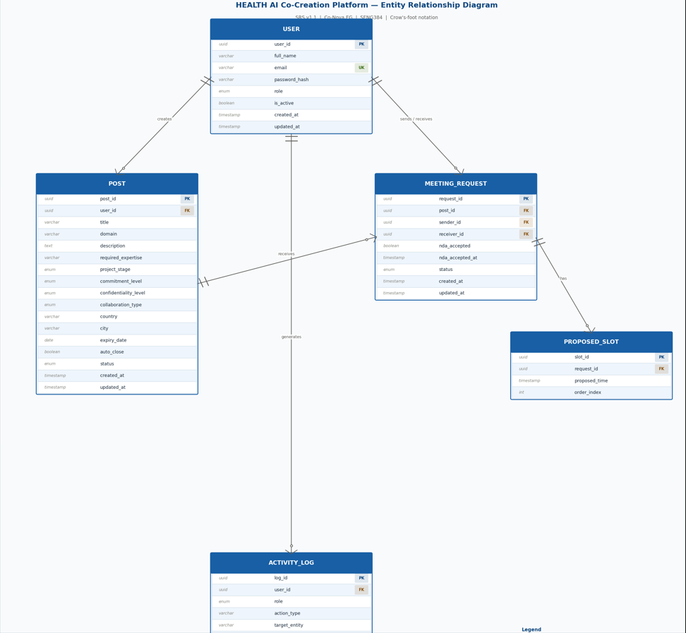
Figure 1– ER diagram

9.2 Use Case Diagram
The use case diagram illustrates the interactions between system actors
and the HEALTH AI platform.

The main actors include Engineers, Healthcare Professionals, and
Administrators. The diagram presents the primary system functionalities
such as post creation, browsing collaboration opportunities, meeting
request workflows, and administrative moderation.

It provides a high-level overview of how users interact with the system
to initiate interdisciplinary collaboration.

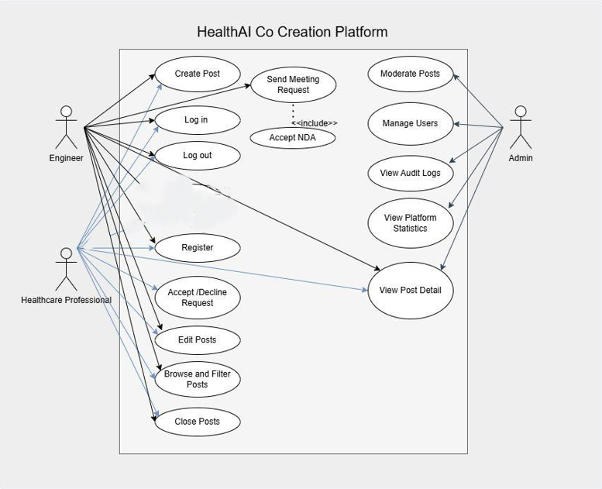
Figure 2- HEALTH AI Use Case Diagram

9.3 Wireframe Screens
9.3 Wireframe Screens

This section presents the low-fidelity wireframes of the HEALTH AI platform,
based on the implemented frontend prototype.

The wireframes illustrate the main user interface screens and core interaction
flows, including Landing Page, User Registration (Engineer & Doctor),
Dashboard, Browse Posts, Create Post, My Posts, Requests Management,
Meetings, and Profile pages,Admin panel.

These visual designs demonstrate how users navigate through the platform
and perform key actions such as account creation, posting collaboration
requests, browsing available projects, sending and managing requests,
and scheduling meetings.

The wireframes are derived from the current frontend implementation and
represent the intended user experience and system functionality.

1. Landing Page
Description:
The Landing Page is the initial interface presented to users and introduces the purpose and value of the HEALTH AI platform.
Key Features:
- Platform title and tagline
- Call-to-action buttons (Sign In, Join Platform, Schedule a Consult)
- Informational sections:
  - For Healthcare Professionals
  - For Engineers
  - Security & Compliance
Purpose:
To inform users about the platform and guide them toward registration or login

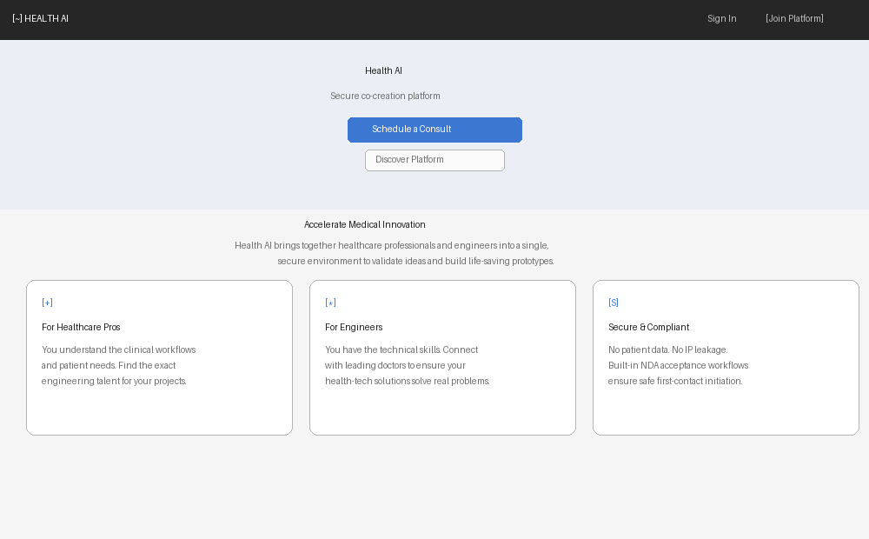

2. Sign In Page
Description:
This page allows registered users to securely log into the system.
Key Features:
- Institutional email input (.edu required)
- Password input
- Sign In button
- Navigation to Register page
Requirements:
- The system shall validate user credentials.
- The system shall display an error message for invalid login attempts

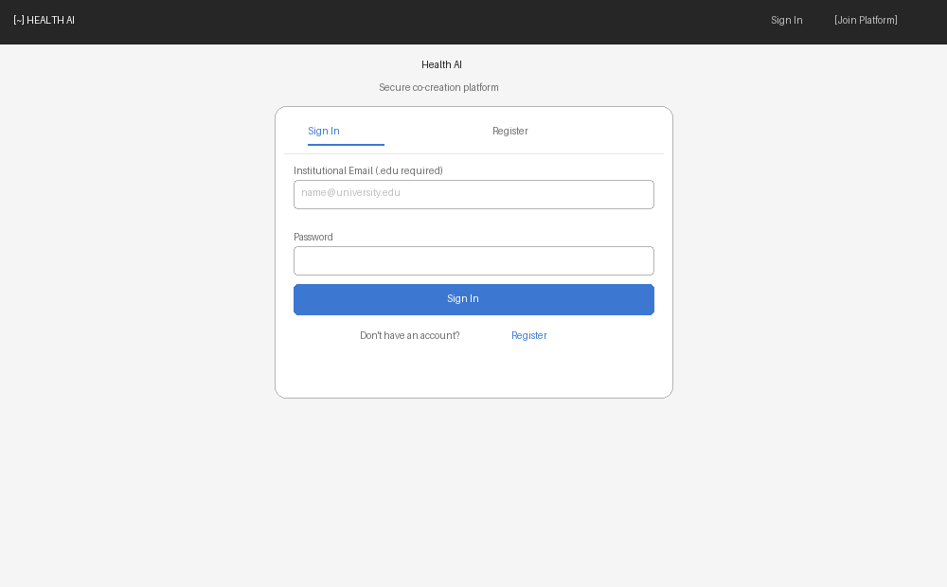

3. Register Page
Description:
This page enables new users to create an account on the platform.
Key Features:
- Full Name input
- Institutional email input (.edu required)
- Password input
- Role selection (Engineer / Healthcare Professional)
- Domain selection dropdown
- Create Account button
Requirements:
- The system shall enforce institutional email validation.
- The system shall store user role and domain information
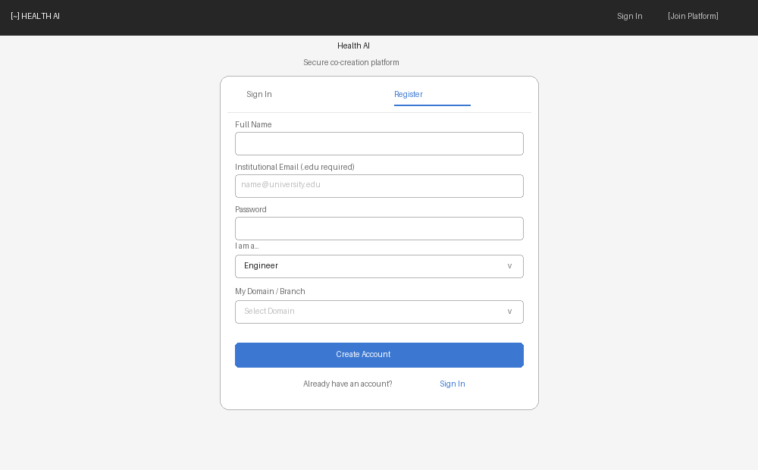

4. Dashboard – Engineer
Description:
This dashboard provides engineers with access to clinical needs and collaboration requests.
Key Features:
- Navigation bar (Dashboard, New Post, Profile & Requests, Notifications)
- Access to “Find Clinical Needs”
- Overview of requests and activities
Purpose:
To allow engineers to explore healthcare problems and manage collaboration requests

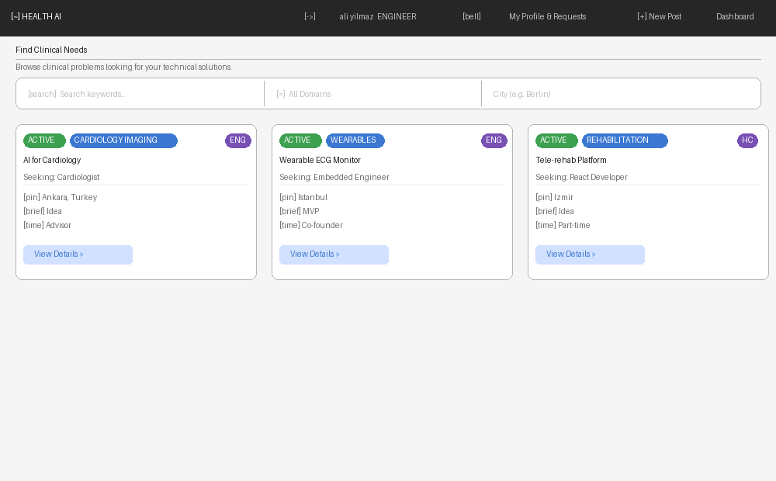

5. Dashboard – Healthcare Professional
Description:
This dashboard provides healthcare professionals with tools to find engineering partners.
Key Features:
- Navigation bar (Dashboard, New Post, Profile & Requests, Notifications)
- Access to “Find Engineering Talent”
- Overview of created posts and incoming requests
Purpose:
To enable healthcare professionals to initiate and manage collaborations

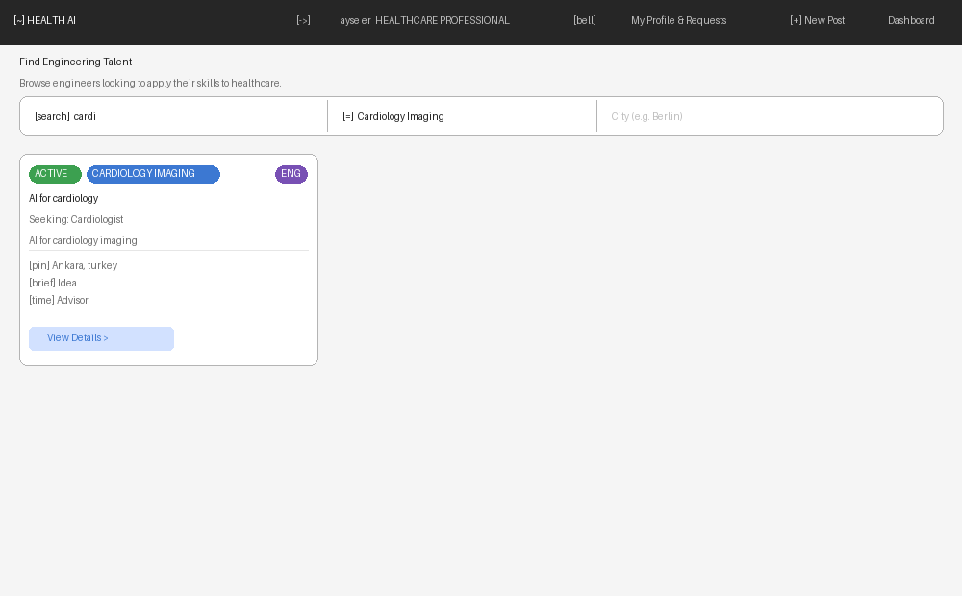

6. Create Post – Step 1 (Basic Information)
Description:
The first step of the post creation process where users enter general project details.
Key Features:
- Post Title input
- Working Domain selection
- Project Stage selection
- Country and City inputs
- Next button
Requirements:
- The system shall require all mandatory fields before proceeding

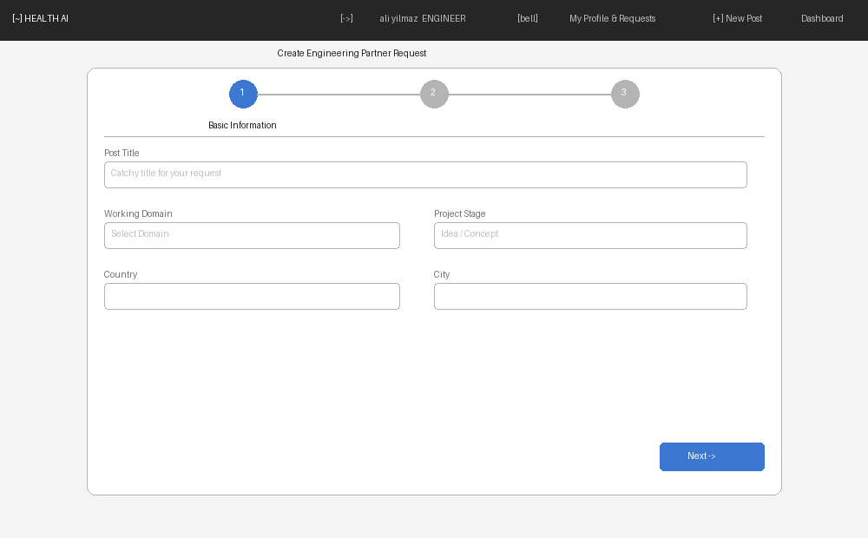

7. Create Post – Step 2 (Details & Requirements)
Description:
The second step where users provide detailed project information.
Key Features:
- Short explanation input
- High-level idea input
- Desired expertise input
- Level of commitment selection
- Next / Back buttons
Purpose:
To define collaboration expectations clearly

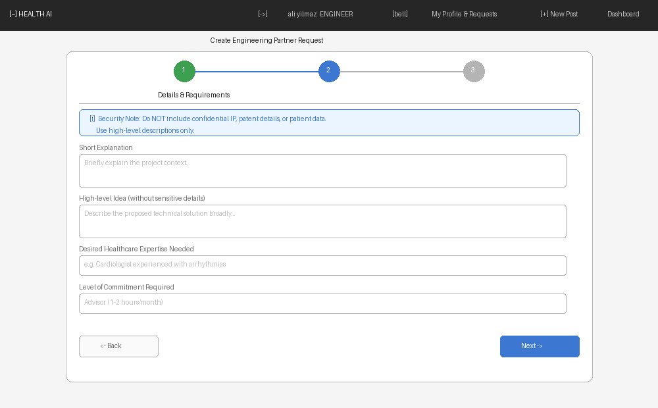

8. Create Post – Step 3 (Post Configuration)
Description:
The final step where users configure visibility and publish the post.
Key Features:
- Confidentiality level selection
- Expiry date input
- Auto-close option
- Post preview section
- Publish Announcement button
Requirements:
- The system shall allow users to review before publishing

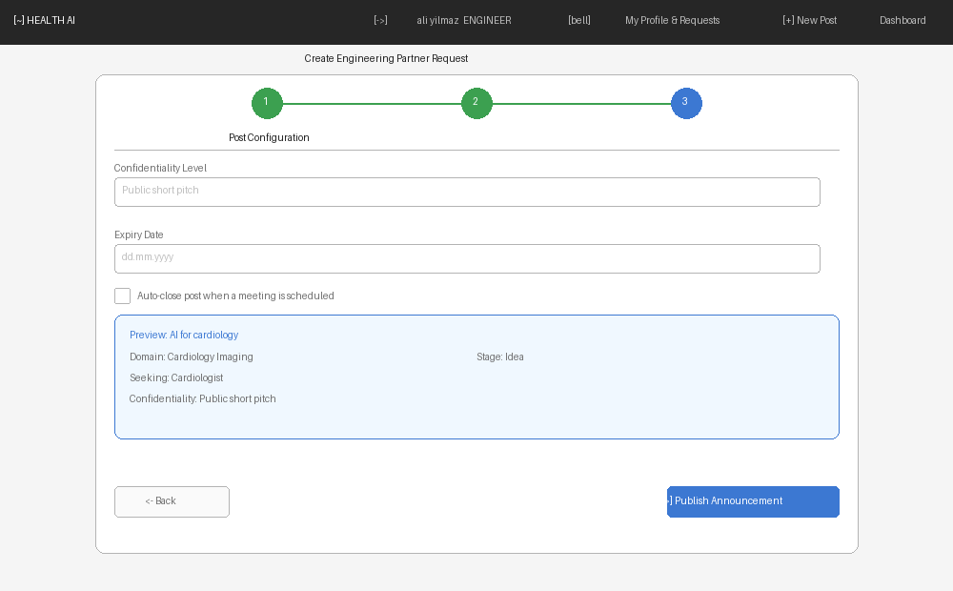

9. My Profile – My Announcements
Description:
This page displays all announcements created by the user.
Key Features:
- List of posts
- Status indicators (Active / Closed)
- Action buttons:
  - Edit
  - Mark Partner Found
  - Archive
Purpose:
To manage and track user-created posts

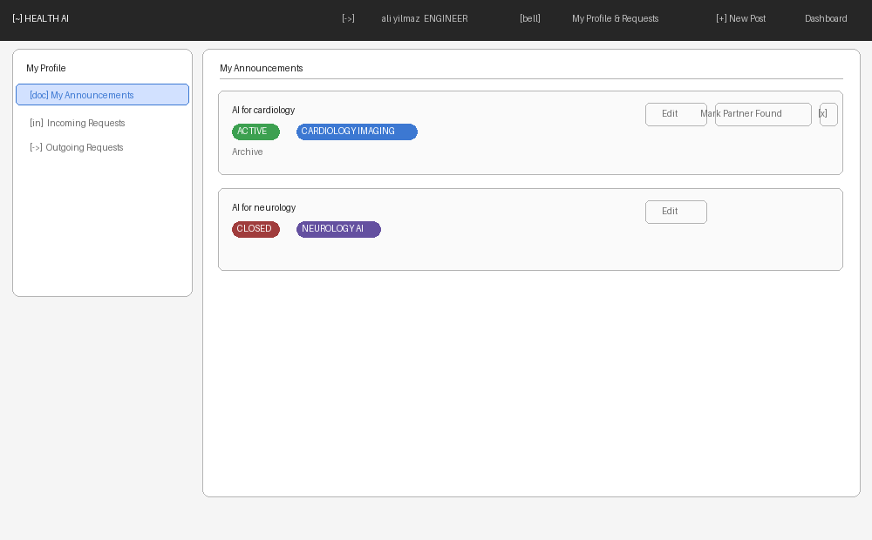

10. My Profile – Incoming Requests
Description:
This page shows all collaboration requests received by the user.
Key Features:
- Request list
- Status indicators (Pending / Scheduled)
- Action buttons:
  - Propose Time & Accept
  - Decline
Purpose:
To allow users to respond to incoming collaboration requests

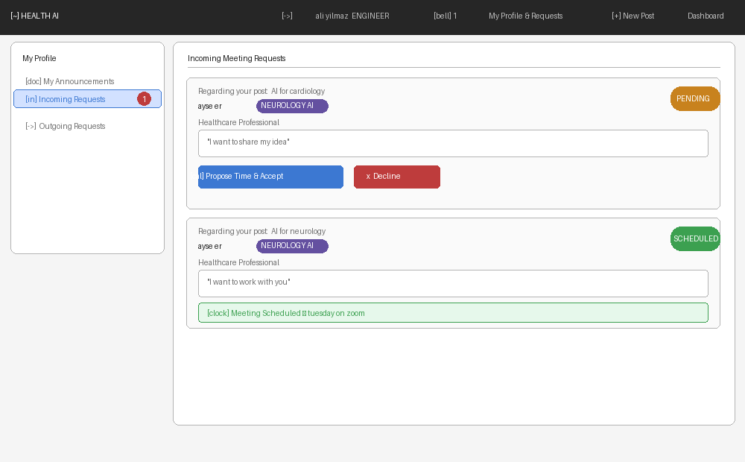

11. My Profile – Outgoing Requests
Description:
This page displays all requests sent by the user.
Key Features:
- List of sent requests
- Status indicators
- Meeting details (if scheduled)
Purpose:
To track the status of outgoing collaboration requests

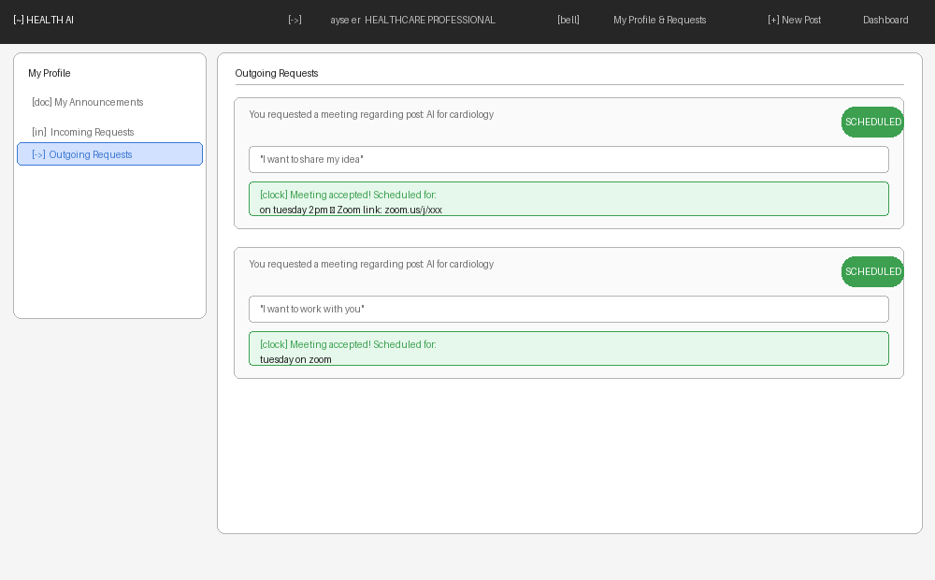

12. Request Meeting Modal
Description:
A modal interface used to initiate a meeting request.
Key Features:
- Introductory message input field
- NDA agreement checkbox
- Send Request button
- Cancel button
Requirements:
- The system shall require NDA acceptance before submission

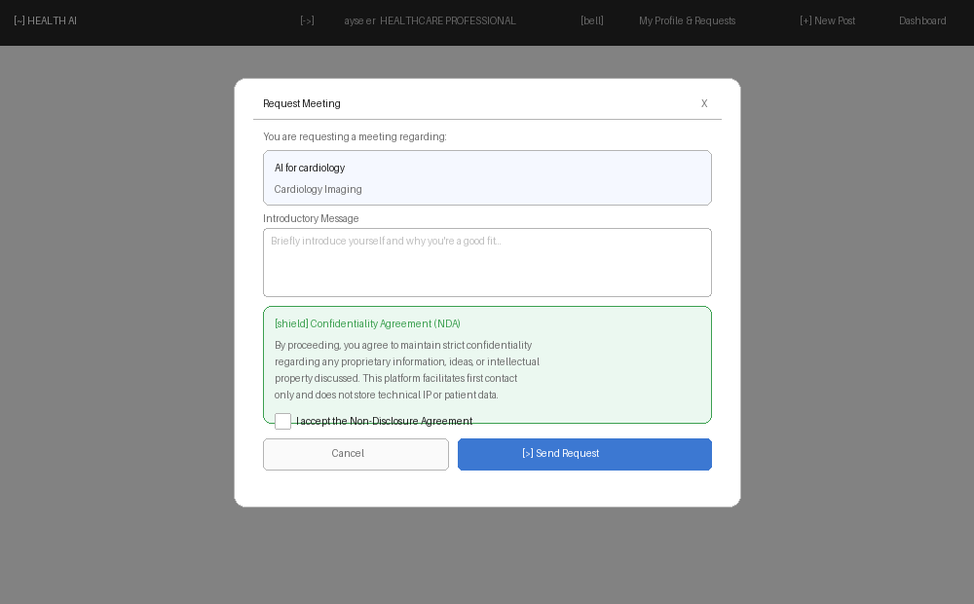

13. Propose Time Modal
Description:
This modal allows users to propose a meeting time after accepting a request.
Key Features:
- Meeting time input
- Optional meeting link (e.g., Zoom)
- Confirm and Cancel buttons
Purpose:
To finalize scheduling details between users

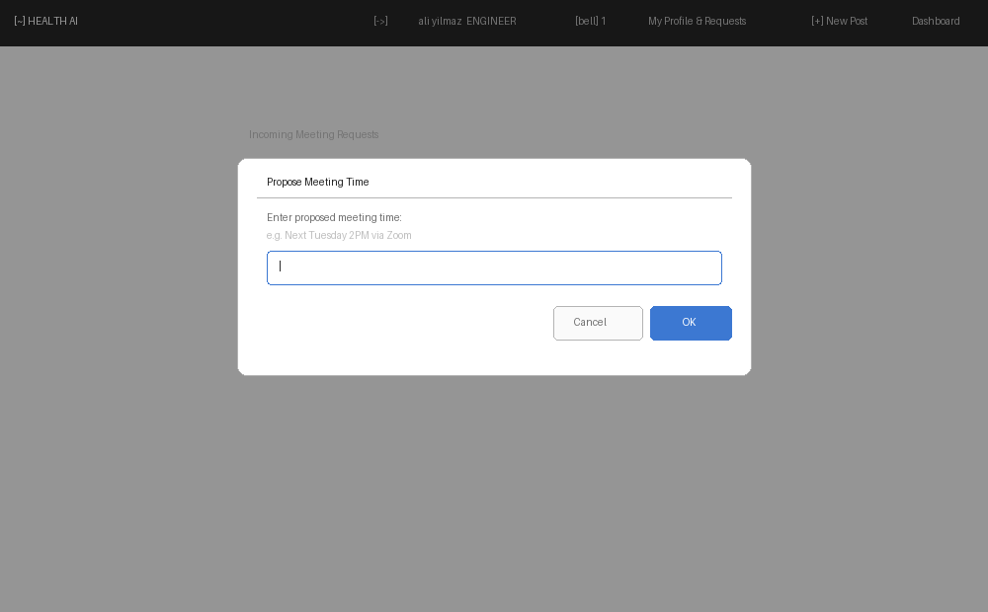

14. Edit Announcement Page
Description:
This page allows users to modify an existing announcement.
Key Features:
- Editable fields:
  - Title
  - Domain
  - Stage
  - Location
  - Description
- Save Changes button
Requirements:
- The system shall update the post after successful validation

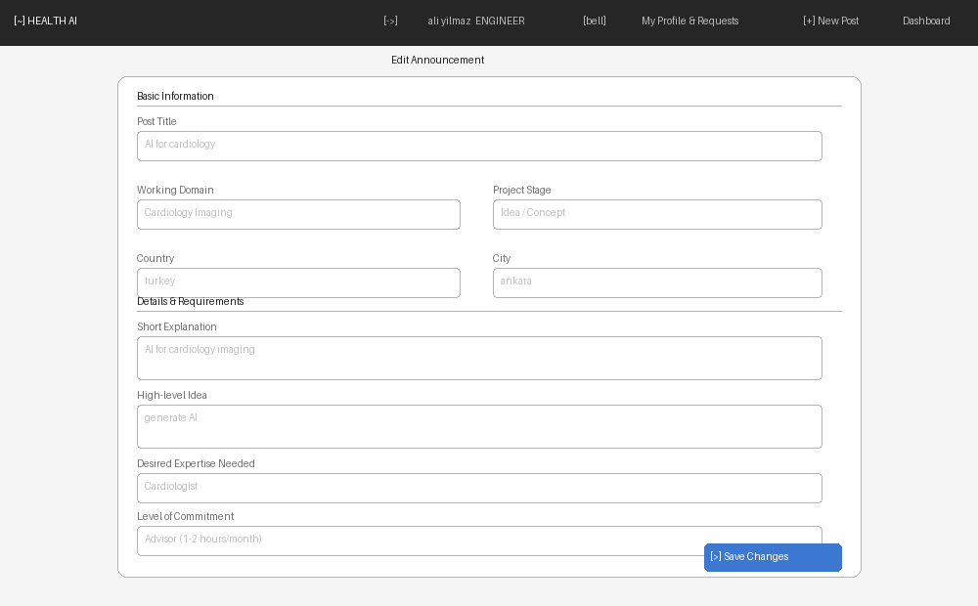

15. Account Settings Page
Description:
This page allows users to manage their account and profile settings.
Key Features:
- Editable fields:
  - Full Name
  - University
  - Domain (dropdown)
- Read-only fields:
  - Email
  - Role
- Update Profile button
Additional Features:
- Export user data option
- Delete account option
Requirements:
- The system shall restrict editing of email and role fields.
- The system shall allow secure account updates and deletion

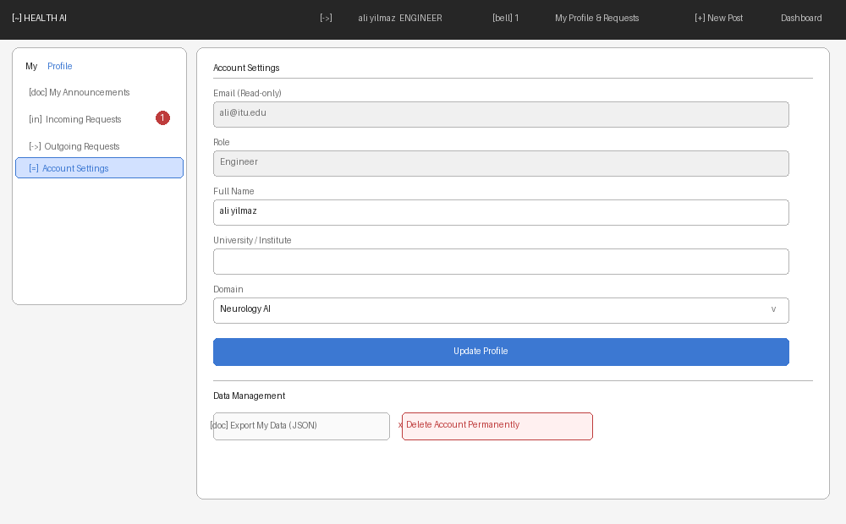

15. Admin Dashboard Page
This interface provides administrative tools for managing the platform.
Administrators can monitor posts, manage users, review audit logs, and analyze platform statistics.The dashboard supports moderation and compliance monitoring

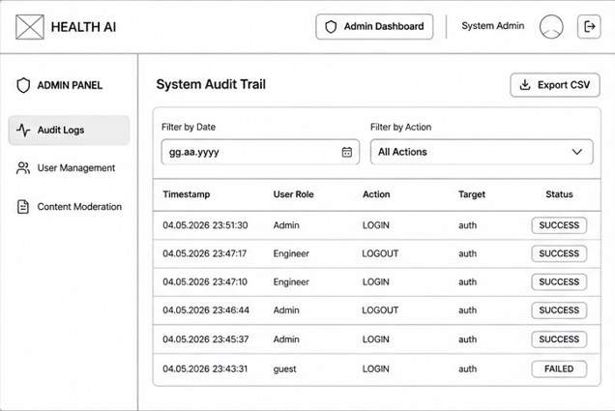
Figure 17-Admin Dashboard
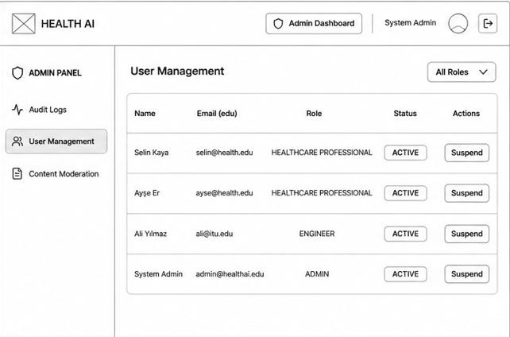
Figure 18- Admin Dashboard 2
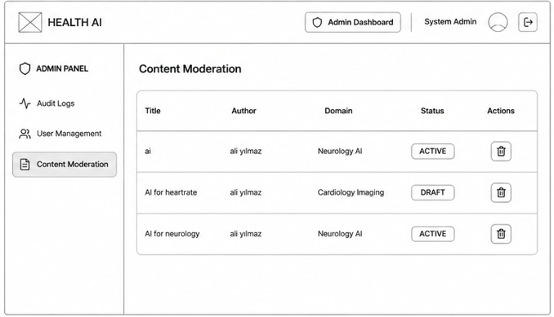
Figure 19-Admin Dashboard 3

